Insert your name, centre number and candidate number into the header above.
Save this evidence document as evidence_ followed by your centre number_ candidate number. For example: evidence_ zz999_9999
Screenshots or program listings must be copied into appropriate cells in the following tables.
Examiners must be able to read the contents including any screenshots without the use of a magnifying glass. Answers that are not readable or missing will not be awarded any marks.
Save this evidence document at regular intervals, for example, every 10 minutes.
Question 1
Part 1(a)
global StackData
global StackPointer
#DECLARE StackPointer : INTEGER
#DECLARE StackData : ARRAY[0:9]
StackPointer = 0
StackData = [0, 0, 0, 0, 0, 0, 0, 0, 0, 0]

Part 1(b)
def PrintArray():
global StackData
global StackPointer
print("The Stack Pointer is", StackPointer)
for x in range(10):
print(StackData[x])

Part 1(c)
def Push(value):
global StackData
global StackPointer
if StackPointer > 9:
return False
else:
StackData[StackPointer] = value
StackPointer = StackPointer + 1
return True

Part 1(d)(i)
for x in range(0,11):
value = int(input("Enter the number: "))
if Push(value) == True:
print("Successfully Added")
else:
print("The Stack is Full")

PrintArray()

Part 1(d)(ii)
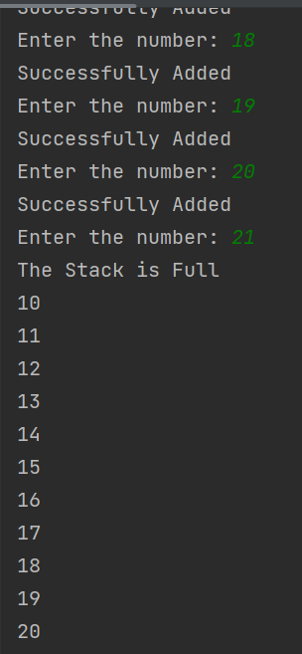

Part 1(e)(i)
def Pop():
global StackData
global StackPointer
if StackPointer == 0:
return -1
else:
StackPointer = StackPointer - 1
temp = StackData[StackPointer]
return temp

Part 1(e)(ii)
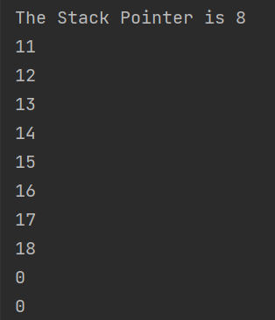

Question 2
Part 2(a)
class QuestionClass():
#PRIVATE Question : STRING
#PRIVATE Answer : STRING
#PRIVATE Difficulty : INTEGER

def __init__(self, QuestionP, AnswerP, DifficultyP):
self.__Question = QuestionP
self.__Answer = AnswerP
self.__Difficulty = DifficultyP

def GetQuestion(self):
return self.__Question

def GetDifficulty(self):
return self.__Difficulty

def GetAnswer(self):
return self.__Answer

Part 2(b)
class QuizClass():
#PRIVATE Questions : ARRAY [0:19] OF QuestionClass
#PRIVATE NumberofQuestions : INTEGER
def __init__(self):
self.__Questions = [QuestionClass("","",0)] * 20
self.__NumberofQuestions = 0

Part 2(c)
def AddQuestion(self, QuestionObject):
if self.__NumberofQuestions < 20:
self.__Questions[self.__NumberofQuestions] = QuestionObject
self.__NumberofQuestions = self.__NumberofQuestions + 1
return True
else:
return False

Part 2(d)
Question1 = QuestionClass("What is 100/5 ?", "20", 1)

FirstQuiz = QuizClass()
FirstQuiz.AddQuestion(Question1)
Question 3
Part 3(a)
# DECLARE numData : ARRAY [0 : 9] OF INTEGER

numData = [10, 4, 23, 45, 12, 8, 21, 11, 3, 1]

Part 3(b)(i)
#we can not take parameter by reference so that's why taken as global
def BubbleSort():
# DECLARE Noswaps : Boolean
# DECLARE y, temp : INTEGER
global numData
Noswaps = False
Boundary = 9
while Noswaps == False:
Noswaps = True
for y in range(Boundary):
if numData[y] > numData[y + 1]:
temp = numData[y]
numData[y] = numData[y + 1]
numData[y + 1] = temp
Noswaps = False
Boundary = Boundary - 1

Part 3(b)(ii)
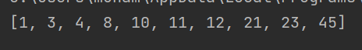

Part 3(c)(i)
def EvenNumber(arrayname):
count = 0
for x in range(len(arrayname)):
if (x % 2) == 0:
count = count + 1
return count

Part 3(c)(ii)
Evencount = EvenNumber(numData)
print("Even Number Are:",Evencount)

Part 3(c)(iii)
